1. **Agenda**:
   1. How to configure the consumer MSs so that they read only committed msgs.
2. When Producer Transfer MS will send msg in a kafka Transaction, those published msgs will be invisible to the consumers if they are configured to read only committed msgs. Those msgs will be visible to them only if the kafka Transaction is committed.
3. 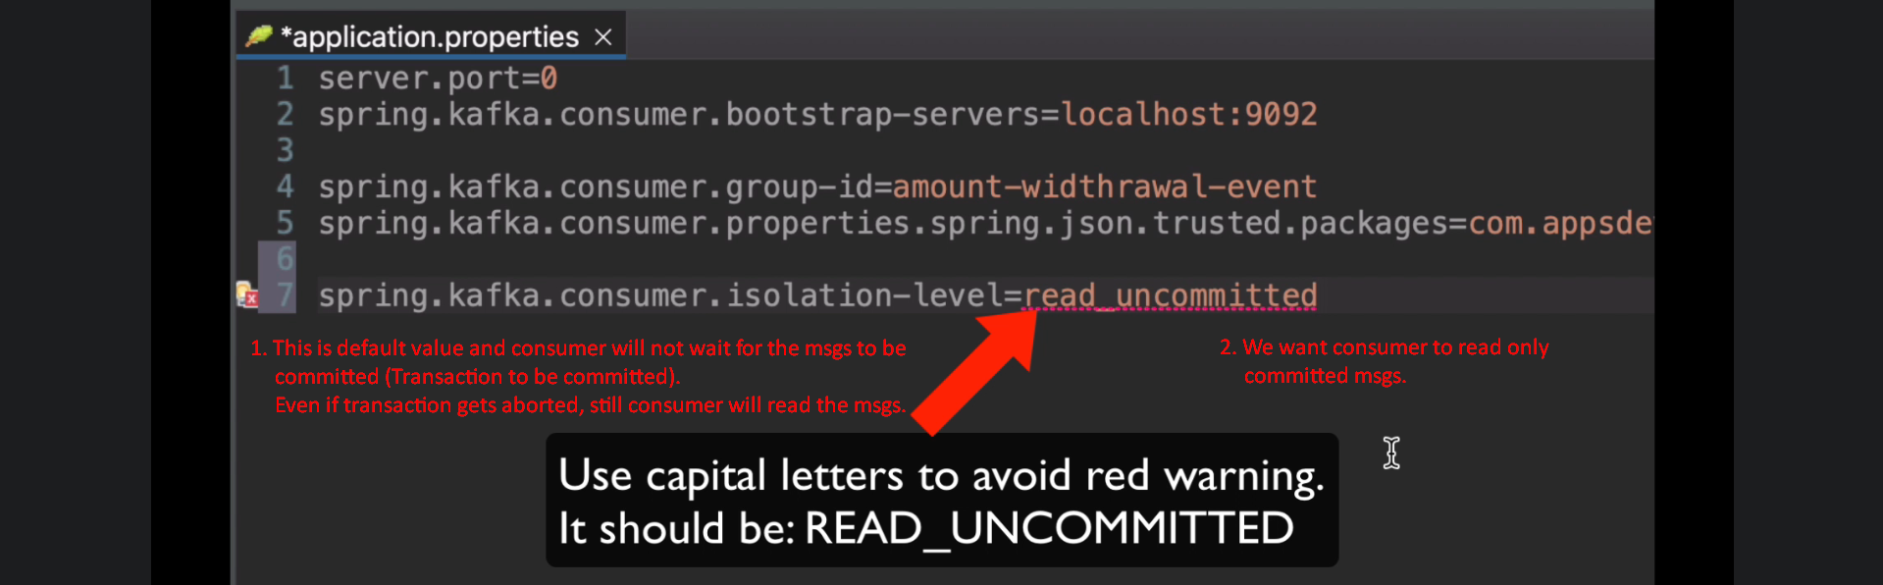
4. The following is from Withdraw MS.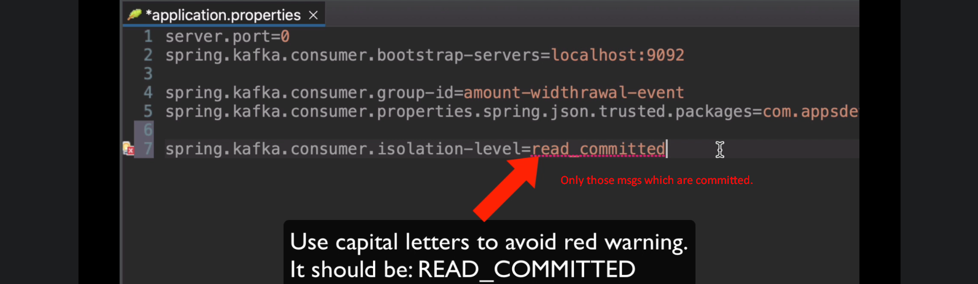  
   IDE or compiling tries to map the properties to KafkaProperties.consumer.isolationLevel which is **enum** like below. So, it expects in Upper Case for type-safe bindings. This enum is by Spring Boot.   
     
     
   
5. You can also set the isolationLevel by Java code like this. The lower in lowercase works as Kafka Client Library (Lower Class) requires the value in lower case. 